
PLEASE DO NOT TURN IN A PAPER COPY. THIS INFORMATION IS FOR YOUR REFERENCE ONLY. ALL APPLICATIONS MUST BE TURNED IN ON-LINE. ONLINE APPLICATIONS CAN BE FOUND ON THE smmsspartans.org WEBSITE.

ST. MARGARET MARY SCHOOL

GRADES 1-8 APPLICATION (2022 – 2023)

Date of Application

F A M I L Y

P H O T O G R A P H

Please clip here.
This photo will not be returned.

Grade applying to
Previously applied? No Yes Year
PARISH INFORMATION

Are you registered in St. Margaret Mary School
Parish? Yes____ No_____
Are you an active member? ________
SMMS Church envelope number
Another Parish?
Do you regularly participate in
Sunday Mass?
Is your child of another faith?
Have you or any member(s) of your family attended SAINT MARGARET MARY School?
Name (s) Year

APPLICANT INFORMATION
Student’s Legal Last Name First Middle

Mother’s Legal Last Name _____________________________ First______________________

Father’s Legal Last Name ______________________________ First ______________________

Address ______ City State Zip
Phone (most accessible)

Male Female Age mos. Date of Birth Place of Birth

Email Address
SACRAMENTAL INFORMATION (Please Provide Copies)
Date of Baptism ________ Verified
Church of Baptism City/State
Date of First Communion Verified
Church of First Communion City/State ______
FAMILY INFORMATION: Father Mother

Name:
First Middle Last First Last

Marital Status: Married Separated Divorced Married Separated Divorced

Single Parent Deceased Single Parent Deceased

Place of Birth:
Religion:
Occupation:
Employed By:
Business Address:
Phone No:

Please list all adults and children living at home with applicant:

Name Age Relationship Name Age Relationship

Child's Present/Previous School Name Address City, Zip
Has your child previously attended Kindergarten? Yes No

May we contact the child's current teacher for recommendation? Yes No

Name of teacher Phone

Are you aware of any learning, physical, emotional difficulty with your child? Yes No
If "Yes", please give an explanation of your child’s challenge and attach any private testing/evaluations your child has received. This information will help us to better plan your child’s educational programs. (*)

Does your child currently have an Individual Educational Plan (IEP) from your home school district and/or does your child receive special services through your public school (such as speech/language services, occupational therapy, physical therapy, social skills support, or counseling)? Yes No
If “Yes”, please give an explanation of your child’s challenge and attach a copy of your child’s most current IEP. SMMS may request copies of any evaluations your home school district has administered to your child. This information will help us to better plan your child’s educational program. (*)

(*) Failure to communicate any of the above information to SMMS could result in a delay in processing your application and could also affect admission status.

Are there any legal decisions involving your child of which school should have knowledge?

Does your child presently take any regular medication?

Please list your current parish/school activities.

Why do you wish to enroll your child in Saint Margaret Mary School?

SAINT MARGARET MARY SCHOOL ADMISSIONS

Saint Margaret Mary Catholic School is the best choice to prepare your child

academically, emotionally, and spiritually in today’s world.

Our smaller school size means we offer a community of close-knit faculty, parents and students. We all come together in our desire to raise our children in a faithful community and a dedication to their academic successes. We welcome you to join our SMMS family!

The hallmark of our education is our faith and our Catholic values - We provide our students the opportunity to practice their faith with their peers and to participate as prayer leaders of the weekly celebration.

Our strong academic program expands our curriculum to include foreign language, life skills, values, fine arts, and technology into the curriculum. We are fully accredited by the Western Catholic Educational Association, and we have strong standardized scores at all grade levels.

Our innovative approach incorporates the use of technology in the classroom. All students in Kindergarten - 8th grades are assigned an iPad.

Our classroom size averages 24-26 in our elementary grades and 27-32 in our junior high grades.

Our number one strength is our community, our students, our staff, clergy, families and alumni. Feedback from many families who have moved out of the area is to "treasure your community at Saint Margaret Mary School; it is a special place full of love and caring individuals"

Our strong outreach program gives our students the opportunity to through the support and partnership of St. Margaret Mary Christian Service Program, and several other organizations, teaches students in all grades about giving back to those in need

Admission Policies
General Information
Students who desire an educational experience founded on the Catholic philosophy of education and who fulfill the age, health, and academic requirements are eligible for admission to St. Margaret Mary School. Saint Margaret Mary School follows the policies of the Archdiocese of Los Angeles and does not discriminate on the basis of race, color, gender, and/or national or ethnic origin in the administration of educational policies, athletic and other school administration programs. Equal opportunity is provided for both students and employees. Admission to the kindergarten program will be based upon the following admission priorities:
- Students entering kindergarten must be five (5) years of age by August 1st year of enrollment. St. Margaret Mary School cannot grant any waivers unless certain academic criteria for early admission is met.
- Families and new students seeking admission to grade T.K through grade 8 on a space available basis must submit all prior school records for evaluation and be personally interviewed by the principal and faculty representatives to determine if Saint Margaret Mary Catholic School can satisfy the academic needs of the students.
- The Birth Certificate and Baptismal Certificate must be presented at the time of registration.
- Registration is not complete until all the necessary paperwork and a non-refundable registration fee is submitted.

Admission Priorities
Candidates for admission to grades Pre- K through 8th grade will be granted admission based on the following priorities:
- The school will give preference to current students by allowing re-registration each year prior to registration for new students. Accordingly, first priority will be given to students currently enrolled in Saint Margaret Mary School, who successfully completed the Kindergarten Program or their previous year of school study, and who re-register.
- In the event there are more qualified candidates than available admission openings, the admission priority will be given to the children of families who have been registered and participated in the parish envelope system for the longest period of time prior to the year of the new child’s admission.

Admission Discretion
Admission from any of the pool of candidates set forth above will be made in the sole and absolute discretion of the principal and the pastor.
Review of Records
In order to meet the individual needs of each student, we must first assess a student’s level of academic development. If a child’s record of academic achievement is incompatible with the program presently administered in the school, then it will be impossible to enroll that student.
NOTE:
To enable St. Margaret Mary School to perform an adequate record check, parents should provide any report cards and/or information from the prior school. Upon receiving an application for registration, Saint Margaret Mary School will send for the records of the student from the prior school. Admission is predicated upon receiving all previous school records prior to matriculation at St. Margaret Mary School.
Evaluation Period
All new students accepted in Levels TK-8 are given a 2 -4 month evaluation period. If during this time, the principal determines that the school is unable to meet the needs of the student, the parents will be required to place their child in another school. Such a recommendation would occur after a conference with the parents.
Admission to Class
Any child who attends St. Margaret Mary School must meet the requirements of the school, the California State Health Department of Education and the Archdiocese of Los Angeles. Accordingly, the following requirements are necessary for attendance at St. Margaret Mary School:
- All medical records must be up to date as required by the Los Angeles County Health Department.
- Each student MUST have a current emergency contact information on file in the school. Parents’ home telephone numbers as well as information on any health problems a child may have MUST be on file. This information must be updated through the year as changes occur.
- All financial obligations must be paid.

Tuition & Fees

2022-2023 Tuition and Fees
Education carries many costs – technology upgrades, resource materials, personnel, building maintenance, utilities – all with increasing price tags. Tuition is significantly lower than the actual cost to educate each child due to the commitment of the Archdiocese Education Foundation, our generous donors and the variety of fundraisers that subsidize tuition. Teachers, administrators and staff work together to ensure that our schools are Christ-centered, academically excellent, and welcoming communities, preparing students to be life-long learners and leaders energized by fidelity to Christ, the Church, and one another.
It is our goal to help as many families as possible provide a Catholic school education for their children. The Archdiocese of Los Angeles- Catholic Education Foundation Fund is making scholarship awards and financial assistance available for the 2022-23 school year. Funding for awards is available on a first-come, first-serve basis. The earlier families complete their applications, the better their chances of receiving financial assistance. If you need financial aid assistance, please submit an application for financial aid upon registration. Applications for financial assistance can be found below. Please know that all financial aid documents must be thoroughly completed. Additionally, required copies of your yearly tax forms must be submitted with the completed application otherwise financial aid cannot be given. All financial aid is considered and rewarded based upon ‘need.’ Tuition (TK-8) The annual tuition for 2022-2023 is $4890
The annual tuition and fees are billed over 12 months from June to May. Your FACTS tuition account can only be activated when enrollment is completed and the registration fees are paid for all children attending. Tuition and fees must be paid directly to FACTS Tuition by the designated due date. Payments cannot be accepted at the school.
Annual Tuition Obligation: This amount will be lower if you are eligible to apply for and receive financial aid, or are the recipient of a legacy or transfer grant.
Please refer to the table below to identify your family’s annual tuition obligation.

TUITION
# of Children  (TK-8) | 2022-2023  Tuition Rate  Parish rate | 2022-2023  Tuition Rate  Non-Parish rate | Monthly payment  Tuition divided by 12 months
1 | $4890 | $5190 | $407.5 / $ 432.50
2 | $8530 | $9080 | $710.84 / $ 756.67
3 + | $12270 | $12970 | $1022.50/ $ 1080.84
Additional Fees
Graduation Fee (8th grade): | $125
Sacramental fee (2nd grade only) | $125
General Fee- per family – includes textbooks, insurance, standardized testing, classroom supplies. | Included in tuition
Disaster Kit fees | Included in tuition
Fundraising fee | $200 per student
MOMS Club (P.T.O) Fee | Included in tuition
8th grade Graduation Fee (8th grade only) | $150.00
Fact Tuition Fee | $50.00
Sports Fee | Optional
New Student Application Fee | $60.00
Student picture fee | Optional
Yearbook fee | Optional
Health Room Supplies fee | Included in tuition
Service hours | 30 hours per year
Scrip fee - $450 or $45 a month. Buyer receives full value of purchased card | $450

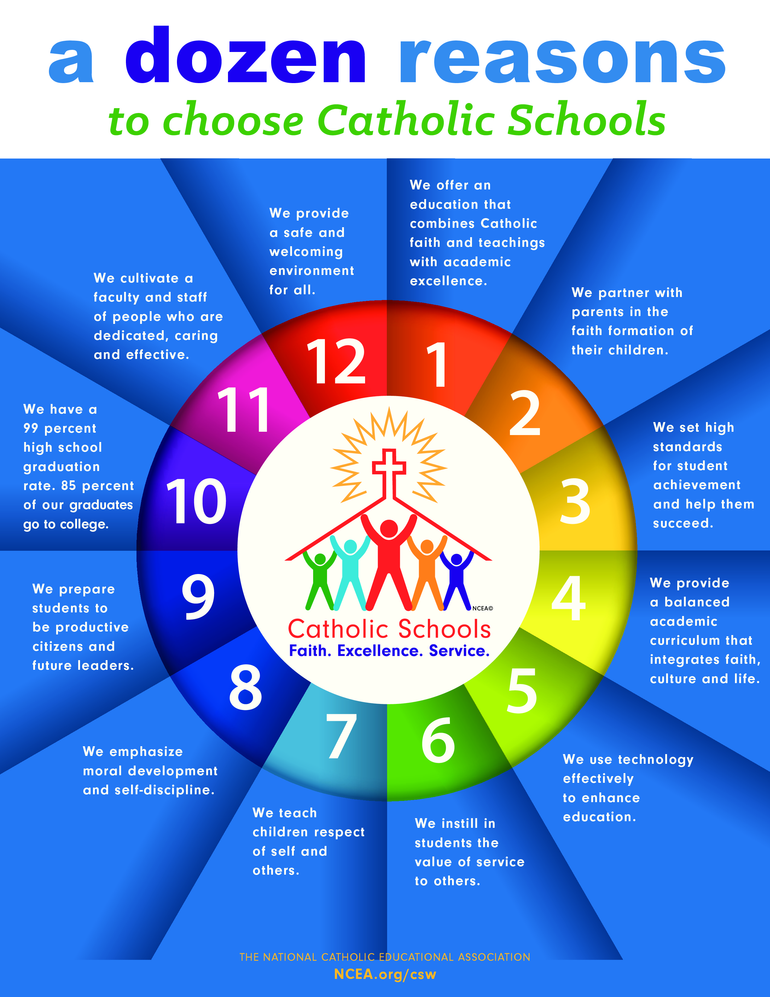

APPLICANT INFORMATION

- Student’s Legal Last Name First
Grade for the 2022-2023 school year__________

- Student’s Legal Last Name ________________________ First _____________________
Grade for the 2022-2023 school year __________

- Student’s Legal Last Name ________________________First _____________________
Grade for the 2022-2023 school year __________

Mother’s Legal Last Name _______________________ First______________________

Father’s Legal Last Name _________________________ First ______________________

Financial Agreement
I acknowledge receipt of the Tuition and Fee Schedule for the upcoming school year and I agree to pay registration, tuition and fees in accordance with the 2022/2023. I also agree to comply with the fundraising fee and SCRIP obligations.
Tuition and Fee
I acknowledge that I am responsible to pay full tuition every month on the day scheduled with FACTS Tuition less any early full-payment discount or approved financial aid or other approved discount. I understand that monthly tuition payments are due through FACTS tuition and non-payment may result in dismissal.
Parental Cooperation Agreement
In full cooperation with the school, I will attend parent/teacher meetings. I have read the Student/Parent Handbook (which can be found at the school’s web site), and will cooperate with the policies and purposes of the school. In addition, we will contribute at least 30 hours of volunteer time to the school. I understand that failure to complete service hours will result in a penalty of $30.00 per each hour not completed. Service hours may not be transferred or exchanged.

Non-discrimination Policy
St. Margaret Mary School admits students of any race, color, gender, and national or ethnic origin to all the rights, privileges, programs, and activities generally accorded or made available to students. The school does not discriminate on the basis of race, color, gender, and national or ethnic origin in the administration of its educational policies, admission policies, financial assistance, and athletic or other school - administered programs
Binding Agreement
Enrollment space is reserved upon the signatures below, but child/children is/are not accepted until payment of the registration fee and receipt of the Financial Agreement as evidenced by a signature of the principal. In consideration for reserving the relevant child(ren)’s place, parent or guardian agrees to comply with all terms and if parent or guardian does not comply, five thousand ($5,000.00) per student or the tuition fee per student, whichever is the lesser amount, shall become due at the start of the school year (commencing July 1, 2022) if the child is not accepted because of noncompliance. The school bases budgetary and spending decisions upon the number of students legally committed to enrollment. It is therefore imperative that this agreement is not signed unless parent or guardian is committed to full compliance and acceptance of student(s). This agreement is enforceable in a court of law. I hereby acknowledge that I have read and understand the preceding agreement and agree to comply with my financial responsibilities. I also acknowledge that my account is current, and will authorize St. Margaret Mary School permission to bill me the registration fee in the amount of $60.00 PER STUDENT on or before March 1 2022. This fee is per student. If payment is received after March 1st, the fee will be $70.00
Signature ______________________________________________ Date ________________
(Parent or Guardian)

Printed name ___________________________________________ Date ________________

SAINT MARGARET MARY SCHOOL TUITION AND FEE SCHEDULE

2022 - 2023
TUITION and FEES

Tuition
(For non- Catholic families and
For Catholic families who
do not regularly attend SMM Church.
Discounted Tuition
Families who attend SMM Church as indicated by weekly family envelopes.

Year Month Year Month

1 student - $ 5190 $ 432.50
2 students - $ 9080 $ 756.67
3+ students -$ 12390 $ 1080.84

1 student - $ 4890 $407.50
2 students - $ 9080 $ 710.84
3+ students -$ 12270 $ 1022.50

- Tuition calculations (above) are based on a 12-month period.

- EARLY PAYMENT DISCOUNT: Families paying tuition in full at the time of submitting a contract will receive a discount of 5.0% tuition amount owed before fees.

Mandatory Fundraising

In the past, Saint Margaret Mary School has always required all our school families to participate in ‘fundraisers’ as a way to offset the costs the school incurs when offering an education of excellence. This is typically through a variety of merchants offering ‘purchasing incentives’ as a way to generate a profit for the school. Upon purchase, the merchant would donate a percentage of the profits to the school. Under this fundraising program, parents were required to purchase from a vendor, a minimum of $400 annually. This year however, we are deleting the “middle man” (vendor) so that the school may realize a larger portion of the profits. We will no longer be requiring our school families to purchase items such as Christmas wrap, cookie dough or miscellaneous items, but rather contribute $16.00 per month, per child to satisfy their financial fundraising commitment. All mandatory fundraising requirements will be now rolled into each family’s tuition commitment.

SCRIP (Gift Card/ Certificates) PROGRAM

Our Scrip Program raises money for Saint Margaret Mary School at no extra cost to you. When families buy scrip gift cards through our school’s scrip program, they receive the full value of what they paid, while earning an immediate rebate percentage to the school – typically between 3% and 15%, depending on the retailer.
Per family – 12-month schedule – 3 options to choose from:
Option #1 - $450.00 Scrip purchase per month.
Option #2 - $225.00 Scrip purchase per month with a $22.50 a month fee
Option #3 - No Scrip purchase – Buyout at $45.00 a month

Service Hours

30 hours of service is required for all school families at Saint Margaret Mary School. If a school family does wish to volunteer 30 hours to the school, they may opt to ‘buy-out’ of their obligation by paying $30.00 an hour. All service hours must be completed by May 1, 2023.
.
Knott’s Berry Farm

It has been a long-standing tradition of St. Margaret Mary School to participate in a community/school wide field trip to KNOTTS BERRY FARM. Every year, the faculty, staff and students of SMMS spend the day at Knotts Berry Farm for ‘school community’ fun! Although the day is spent at the park, it is considered an ‘official school day.’ Tickets/bus fare are sold through the school at $65.00 per package. Students may use their ‘yearly passes’ however a $30.00 bus fee will be charged to their account.

S.M.M.S. 2nd Grade First Holy Communion Fee Information
(applicable to 2nd graders only)

Sacrament Fees. In addition to tuition, a sacrament fee of $75 for each sacrament is required. If a child is celebrating both Penance (confession) and Eucharist, a $150 sacrament fee is required. Baptismal Certificate- If a child has celebrated the sacrament of Baptism at SMMC, we have his/her baptismal certificate on file. If a child was baptized elsewhere, you will need to provide us with a copy of the baptismal certificate.
Parent Meetings. Parents Meetings are conducted for the benefit of those parents whose child is being prepared for the reception of a sacrament. Parent attendance at all scheduled Parent Meetings is mandatory.
First Holy Communion. The celebration of First Holy Communion will be celebrated together as an entire class. The date of that celebration will be determined in May.

8TH Grade Graduation Fee (applicable to 8th graders only)

A $200.00 non-refundable fee will be charged to all St. Margaret Mary School 8th graders. The fee covers the cost of all graduation expenses including cap and gown, awards ceremony, Baccalaureate Mass and the graduation ceremony.

ST. MARGARET MARY SCHOOL BOOKKEEPING INFORMATION
Please fill in the information for both student and parents for the 2022 – 2023 School year.

- Student name _______________________________________________________________
First name last name
Grade_________

- Student name _______________________________________________________________
First name last name
Grade_________

- Student name _______________________________________________________________
First name last name
Grade_________

Responsible Parent Name ____________________________________________________
First name last name

Responsible Parent Name ____________________________________________________
First name last name

MOTHER

- STREET ADDRESS______________________________________________________________

- CITY__________________________________________________________________________

- ZIP CODE______________________________________________________________________

- E-MAIL ADDRESS ______________________________________________________________

- CELL PHONE - _________________________________________________________________

- DAYTIME PHONE - _____________________________________________________________

- EVENINIG PHONE-______________________________________________________________

FATHER - if different from above

- STREET ADDRESS______________________________________________________________

- CITY__________________________________________________________________________

- ZIP CODE______________________________________________________________________

- E-MAIL ADDRESS ______________________________________________________________

- CELL PHONE - _________________________________________________________________

- DAYTIME PHONE - _____________________________________________________________

EVENINIG PHONE-______________________________________________________________

TUITION PAYMENT INFORMATION

There are two options for payment of tuition:
- A 5% discount is given to all school families who pay their tuition obligations in full by the July 1st ^{t} deadline.
- Enroll with FACTS. Families can view their account and have 24/7 access. Twelve tuition payments will be withdrawn on the 5th or 20th of every month from an account that you have selected. The first tuition payment for the 2022- 2023 school year will be deducted in June and thereafter on the 5th or 20th of the month from June 2022-May 2023, making a total of twelve tuition payments.
FACTS Tuition Management
In the events FACTS is unable to withdraw a tuition payment, there will be a $30 penalty payable to FACTS and $25 payable to the school.
‘PARTICIPATING PARISHONER’ - DISCOUNTED TUITION
In order to receive the discounted rate, you are requested to use the parish envelopes to indicate your attendance at Mass. Please remember that our philosophy states that we are preparing our students to, “participate both in the spiritual and liturgical life of the parish…” We ask that you support our goals by attending weekly Mass and participating in the sacraments and parish activities.
The Parent Agreement, which you sign each year states: “I understand that the discounted rate is for parish members who help support the parish through weekly attendance at Mass as indicated by the use of parish envelopes at Mass. Tuition rate will be evaluated and adjusted if necessary prior to the beginning of each semester”.
Envelopes must be handed in at Mass in order for them to indicate participation at Saturday/Sunday Liturgy. They should not be submitted or mailed to the Parish Office. There is no set dollar amount required in the parish/weekly envelope.
If you have any questions regarding this policy, please contact our pastor, Father Paul.

Enrollment Contract
Please check where applicable

Tuition rate A
Participating – a registered Saint Margaret
Mary Church member with an envelope number. #________envelope number One Child $ 4890 $ 407.50 a month ______
Two Children $ 8530 $ 710.84 a month ______
Three Children $ 12270 $ 1022.50 a month ______ ____________________________

Tuition rate B
Non-Participating – not registered with Saint
Margaret Mary Church.

One Child $ 5190 $ 432.50 a month ______
Two Children $ 9080 $ 756.67 a month ______
Three Children $ 12970 $ 1080.84 a month ______

Fundraising
I acknowledge and will fulfill my fundraising obligations. Please bill my account $ a month for each child currently enrolled in the school. ___________

Scrip
I will purchase $450 a month of SCRIP to fulfill my
2022-2023 Scrip obligation. ______

Please bill my tuition account $22.50 a month (for ten months). I will purchase $225.00 a
month thereafter, to fulfill my 2022-2023 Scrip obligation. ______

I do not prefer to buy Scrip. Please bill my tuition account
$45.00 a month (for twelve months) to fulfill my 2022 – 2023 Scrip obligation. ______

School Service Hours ($30.00 an hour)

I will work my required 30 SCHOOL SERVICE hours. ______
I am not able to work the required 30 SCHOOL SERVICE hours. Please bill my tuition account $75 a month over 12 months ______

2ND Grade Sacramental Fees

I am a parent of a 2nd grader.
I understand that my account will be billed $150.00 _______

Technology Fee

$50.00 = $4.17 a month for 12 months _______

Graduation Fee - I am a parent of an 8th grader. I understand that my account will be billed $200.00 for graduation expenses. _______

SAINT MARGARET MARY SCHOOL
Registration Checklist

- BAPTISM CERTIFICATE (COPY) _______

- FIRST HOLY COMMUNION CERTIFICATE (COPY) _______

- BIRTH CERTIFICATE (COPY) _______

- IMMUNIZATION RECORD (COPY) _______

- TRANSCRIPTS FROM PREVIOUS SCHOOL _______

- REGISTRATION FEE PAYMENT OF $60.00 _______ (after March 1st = $70.00)

- FINANCIAL AID FORMS (if applying) _______

- 20 tax forms _______
- W2 _______

- All required information must be submitted to complete the registration process. Incomplete registration packets will be null and void.

SAINT MARGARET MARY SCHOOL FINANCIAL AID FORM

Dear Parents,
Enclosed is information regarding tuition assistance. In order to receive Saint Margaret Mary School tuition assistance, you must first qualify through the CATHOLIC EDUCATION FOUNDATION. To APPLY, you must:
- Complete the CEF form enclosed. When finished, please turn in the form along with required tax documents (most recent TAX FORMS with W2) to my office. I will immediately fill out the remaining necessary paperwork and send it to the CEF office of the Los Angeles Archdiocese. The sooner you do this, the quicker the response!

- I am sorry but tuition assistance WILL NOT be given unless the CEF FORM IS COMPLETED AND TURNED IN.

Sincerely,
Mrs. Zimmerman
Principal



Saint Margaret Mary School

2022 – 2023
REGISTRATION APPLICATION

RE- Registration Packet

