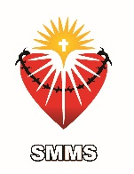

Hello St. Margaret Mary School families,

Happy Monday! So sorry to send this out late however it has been a very busy weekend.

 I spent a lot of my time this weekend attending SMMS sports events. The students representing SMMS are wonderful! They compete hard and exhibit great sportsmanship! Thank you students for being excellent representatives of our school.

Congratulations to Ms. Leyva and her awesome 4th grade class! They received top prizes at the Los Angeles County Fair in Pomona!

Last Tuesday the 8th grade Class ventured off to ‘Our Lady of the Angels’ Cathedral. They were treated to a tour and attended/participated in the Mass. Thank you Class of 2017 for a ‘job well done.’ Your behavior, particularly your respectful attitude towards this incredible House of Worship was excellent!

The mid way mark for the first tri- semester was last Friday, October 7th. Deficiency notices were mailed office. In addition, some students received ACADEMIC PROBATION NOTICES. These notices were given to all SMMS athletes whose current g.p.a is below a 2.0 G.P.A’s will be evaluated every Tuesday.

Today, the 8th grade class will attend their first retreat of the school year! Please pray for them!

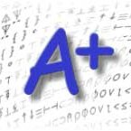Please make a note in your calendar that:

1. October 19th is a ‘no school’ day. Teachers will gather together to work on our WASC document. As you probably are aware of, SMMS will be evaluated this February by the Western Association of Schools and Colleges.
2. 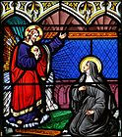The FEAST OF ST. MARGARET MARY All School Mass is this Friday at 8:15 am. The 8th grade will host this tribute to our patron saint. Please join us!
3. Not happy with your child’s school pictures? You may re-do them on Friday October 21st. Envelope order forms are located in your child’s family folder.
4. DRESS FOR CHANGE – Bring a dollar and wear free dress!!! When? October 19th
5. 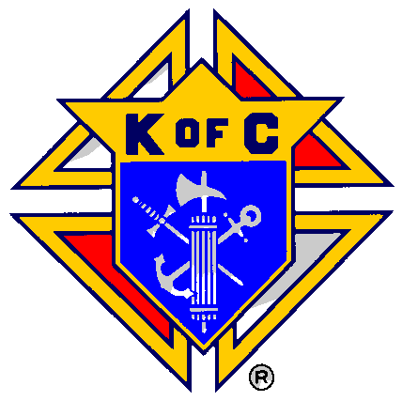Round two of STAR TESTING begins October 24th through Friday the November 4th. Please make sure your child receives a good night’s sleep and a solid breakfast!
6. KNIGHTS OF COLUMBUS VOLLEYBALL TOURNAMENT THIS SATURDAY! More news to follow in your Wednesday family folder!!
7. The Religious Education Department at Saint Margaret Mary Parish has a new Faith Formation Director. Joe Voigt is no longer with the school. Please come by and meet her!
8. HALLOWEEN PARADE! HALLOWEEN is October 31st and so is our traditional parade. The parade begins at 11:00 a.m however students may come to school in their Halloween costume!! Please be ever mindful of our costume rules. No blood, gore or weapons. October 31st is a half day.  HAVE A GREAT WEEK!

Mrs. Zimmerman - Principal