Hello St. Margaret Mary School families,

Happy Sunday!

Well, the kids made it! They successfully completed their first week of school! Yes, they were a bit bleary eyed on Wednesday. However by Friday morning, they were full of energy and enthusiasm!! Thank you Fr. Marinello for your wonderful welcome at the ‘All School Friday Mass.’ Thank you moms of our ‘SMMS Moms Club,’ for providing coffee and baked goods to our parents on the first day of school.
As we proceed to the second week of school, I thought I would jot down a few ‘take-aways’ from last week as well as reminders for the remainder of the month.
- The uniform code of Saint Margret Mary School calls for the students to own three types of uniforms:
- Formal Mass Day uniform – FMD uniform code requires students to wear a SMMS collared shirt, slacks/skirts/jumpers and a sweater or sweater vest. Sweatshirts or jackets are not allowed for Mass.
- No- P.E or Normal Day Uniform– students who do not have Mass nor P.E scheduled for the day, must wear a SMMS collared shirt, shorts/ slacks/skirts/jumpers. SMMS sweatshirts and jackets are allowed.
- Physical Education Uniform - For those students who have physical education with Mr. Calip scheduled on a particular day, P.E shorts, tee-shirts and tennis shoes are mandatory. This uniform code has changed a bit from last year. Royal blue SMMS tee shirts are now the requirement. Although you may no longer purchase last year’s gray tee shirts, you can still wear them if you already have them.
General Uniform requirements
- Bracelets, rings and necklaces are not allowed
- Nail polish or make-up is not allowed
- Girls may wear earrings, however studs only.
- Socks must be white, blue or black. They must also cover the ankle. If a student is wearing ‘high top’ tennis shoes, socks must be visible.
- Girls’ skirts and shorts may be no shorter than 2 inches above the knee.
- Dyed hair is not allowed.
- For rainy and cold days, specific SMMS windbreakers and jackets are the only ‘rainy day’ attire allowed.
- All shirts must be ‘tucked in’ while in the school building.
- Black, blue and white are the only shoe colors allowed. Shoe laces must be of the same color as the shoe or white.
- Dismissal Line procedures – large cones and barriers will be set up every day as an added safety precaution during dismissal. Classroom teachers will stand in front of the horizontal pole barrier within the safety zone when dismissing their students. Parents are not allowed to stand and wait in the safety zone. To pick up children, parents may either:
- Drive up to the car line, remain in the car and wait till their child has permission to walk to the car. - Or
- Park and walk out to the east side of the playground and wait for your child to be dismissed. Below is a picture of the school grounds during dismissal time.
EAST FACING
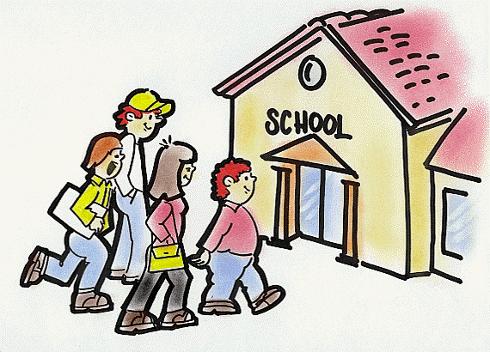
-
School building School Building
Playground (parent waiting area)

Students Dismissal Line Student Dismissal line

Safety Zone (students walking to car line) No parents allowed
Car line
*Please note- parents may not approach a teacher during dismissal. Conversations with parents represent a distraction. If you need to speak to your child’s teacher, please call the office for an appointment.

- Menu Change
For all of those students who ordered ‘HOT LUNCH’ there is a slight menu change. On September 1st, the lunch meal will now be – ORANGE CHICKEN OVER RICE WITH VEGETABLES. TANGERINE AND BOTTLED WATER.
- Homework Club
Homework Club begins August 21st 2017 – If your child is staying for DAYCARE, yet would like to sit in a quiet environment to do their homework, then HOMEWORK CLUB is just the place! Hours are 2:45 – 5:00. Monday through Thursday.
- Star Testing
Star Testing begins at tomorrow! This will be the first of four standardized tests that your child will take. These tests serve as valuable tools to measure your child’s academic growth throughout the year. Please make sure that your child has a hearty breakfast and a good night’s sleep.
- Eclipse on August 21st 2017
People across the United States will have the chance to see a total solar eclipse on Aug. 21. This is the first time the spectacle will be viewable from the continental U.S. since 1979. While it may be tempting to brush off warnings about looking up at this eclipse bare-eyed, don't: The light of an eclipse really can damage your eyes. It is for this reason that the students of SMMS will not be allowed to directly view the eclipse. Although there are certainly safe ways to see it, we don’t have those resources and I cannot run the risk of a child looking straight into the sun unprotected. However, teachers will have eclipse activities for tomorrow and will be watching it live stream.
- Lomita Fair
The Lomita Fair is set to take place on our school campus on September 8th, 9th and 10th. There is no school on September 4th (Labor Day), September 5th, 6th,7th 8th and 11th). School will resume on Tuesday September 12th. DAYCARE will be available during this time.
MONDAY SEPTEMBER 4TH – NO DAYCARE – LABOR DAY
TUESDAY SEPTEMBER 5TH – DAYCARE FROM 6:30 – 6:00
WEDNESDAY SEPTEMBER 6TH – DAYCARE FROM 6:30 – 6:00
THURSDAY SEPTEMBER 7TH – DAYCARE FROM 6:30- 6:00
FRIDAY SEPTEMBER 8TH –DAYCARE FROM 6:30 – 4:00P.M. LOMITA FAIR STARTS AT 5:00 P.M.
- Back to School Night
Thursday August 31ST – ALL SCHOOL ‘BACK TO SCHOOL NIGHT.’ 6:15 p.m. - Meet and Greet with Faculty and Staff Introductions - HEGARTY HALL 7:00 p.m. - Classroom Time – SMMS CLASSROOMS

Have a wonderful week!
Mrs. Zimmerman
Principal

